Dear Mrs. Kaufman,

I am pleased to write to you today to let you know how very dear you husband, Ray, was to the ISSVD.
In order to honor him and his contributions to the ISSVD, the ISSVD decided to create a new award called the Lifetime Achievement Award. This will not be an annual award; it will be reserved for the very few Fellows of the ISSVD who have contributed so significantly throughout their career.

Ray Kaufman most certainly contributed in more ways than I can name here. At the most recent World Congress, held in Paris, France in September 2011, the members and Fellows of the ISSVD gathered, in the presence of your daughter Elisabeth and her husband, David to speak of the many ways Ray helped the ISSVD achieve its mission of educating and treating women.

I have included below copies of the speeches made by some Ray’s closest Fellows of the ISSVD in the order that they presented in Paris. I hope reading these; will help you heal from this great loss.
Additionally, you have received the Lifetime Achievement Award on his behalf and we hope you will enjoy having it to display.

Micheline Moyal Barracco, President

Due to a car accident, Ray Kaufman passed away on November 25, 2010, at the age of 85. Ray was a founding member of the ISSVD and our society wants to honor his memory with a lifetime achievement award, in the presence of his daughter Elisabeth Kaufman De Tone and her husband, David

Unfortunately, I did not have the privilege of getting to know Ray Kaufman well.

However, everything I‘ve heard about him, and what I saw of him during ISSVD meetings, makes me regret not having had the opportunity to know him better.

Ray was an eminent gynecologist, a pioneer vulvar specialist, a stimulating mentor and, above all… an outstanding MAN. Ray was not only a model for those who had the privilege to work with him. For the younger generations, he is an example of what a doctor should be: a subtle mixture of medical competence and humanity. Finally, for everyone, Ray is the demonstration that physical disability can be mastered and overcome by courage and determination to achieve excellence.

Jacob Bornstein, President-Elect
I would like to start by telling how I met Ray. It was in Haifa, Israel in 1983 (28 years ago). He spent a Sabbatical there and gave us a series of lectures on vulvar disease. Talking to him finally led to a two-year fellowship with him.
So in October of 1985 I arrived in Houston, Texas to begin a two-year Post-doc fellowship with Dr. Ray Kaufman, Chair of the Department of Obstetrics and Gynecology at Baylor College of Medicine.
I was impressed by Ray being involved in many aspects of teaching: He taught me cytology and Pathology, as he had a fellowship in pathology after recovering from severe Polio in the 50's. He taught us Colposcopy, Laser treatment and surgery. He set up a program, together with the Virology department, of HPV detection. So the outcome of that fellowship was that I learned a great deal about vulvar disease, but also important – I absorbed from Ray Kaufman some of what I call the wisdom of leadership, knowledge that helped me lately in my position as Chair of a Department of Obstetrics and Gynecology in Israel. Ray was a natural born leader. He always had a good word for you, even when he himself was in difficulties. I owe a lot to Dr. Kaufman, who was a true friend and visited Israel several times, spending time at my unit and supported my research until his tragic death.

Of the many moments I had with Ray, I especially remember a time in 1991. An international congress on Vulvar disease was scheduled in Haifa, Israel and several ISSVD fellows were invited. Those were the days right before the Gulf war, when Saadam Hussein threatened to fire missiles into Israel. At a time when all hesitated, Ray bravely decided to make the trip and come to Israel, and following him, all the invited lecturers felt obligated, so no one cancelled his trip to Israel.
He was brave, and I will always remember him as such.
And of course, Jasmin, my wife, Pat, Ray and I spent time together on many occasions. Pat, your long lasting devotion to him we always admired by us. Thank you for letting us having him for many years.
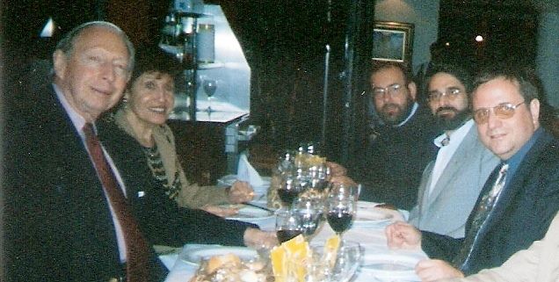
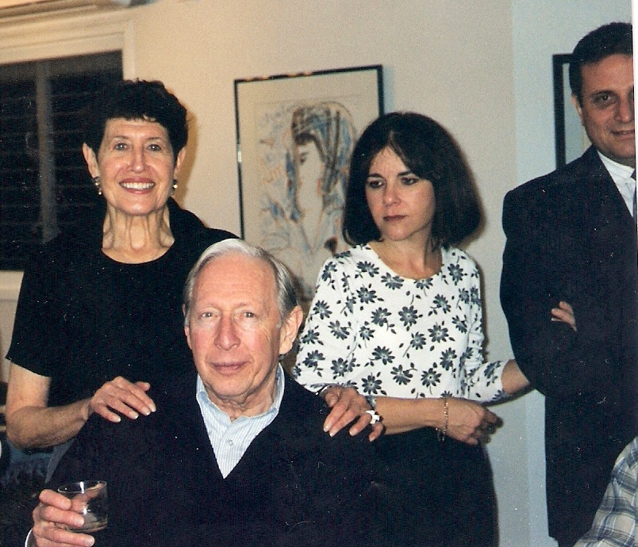
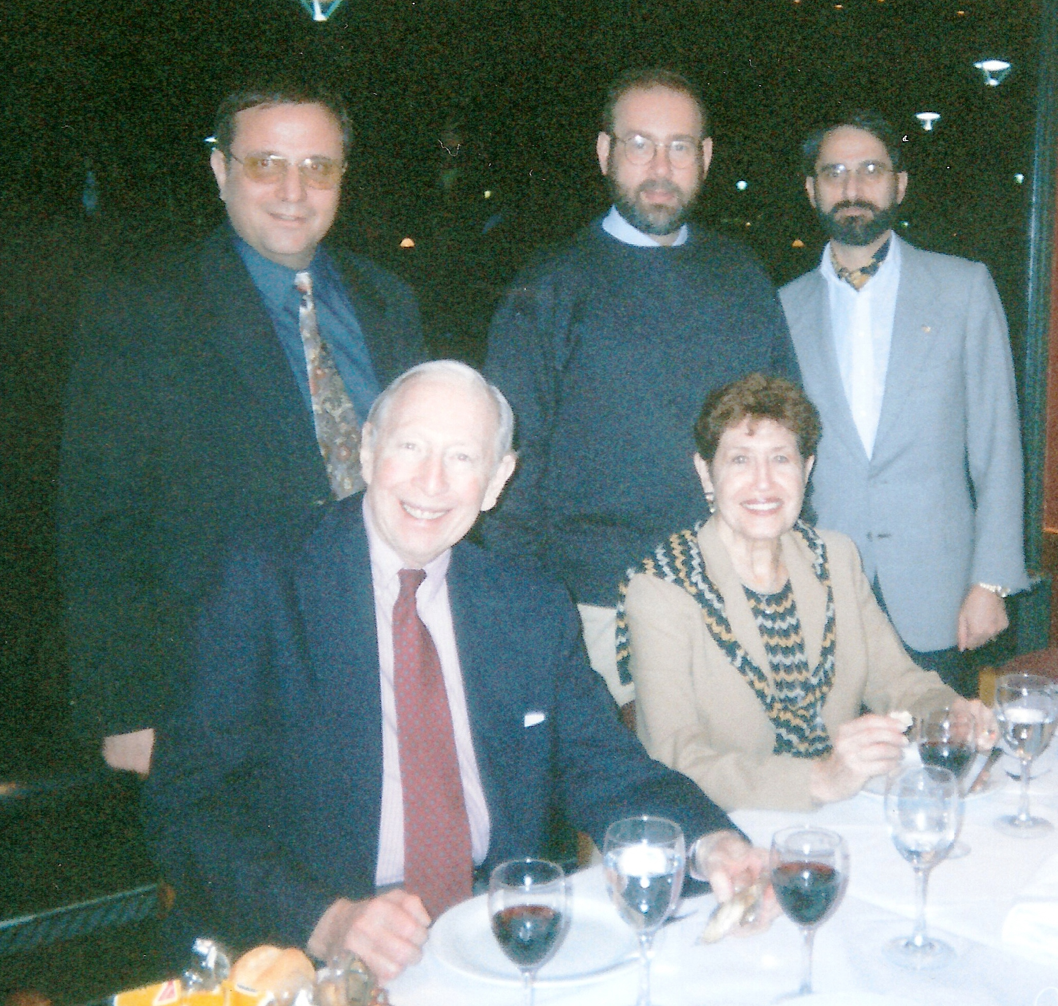

Peter J. Lynch, MD
Novy Professor of Dermatology
University of California, Davis
Past President
I rise to give tribute to a great man-- a man whose greatness extended from a societal to a personal level.
At the societal level, he contributed energy, enthusiasm, industry and productivity. This has resulted in a positive effect of all of us in this room inasmuch as he was an original organizer and founding member of our Society and eventually served as our fifth President in 1979. But even more importantly his greatest gift to all of us was his generosity in sharing his extensive knowledge. This he did this in many ways such as through his participation in essentially every ISSVD program, his organization of nearly 20 biennial Baylor Continuing Medical Education courses and, most of all, through the many editions of “Benign Diseases of the Vulva and Vagina” that he authored and edited. None of us who were aspiring to become vulvologists could have succeeded without these expre4ssions of his invaluable font of knowledge and experience
At the personal level, I became Ray’s colleague 40 years ago in 1970. Shortly thereafter he became one of the most important mentors I’ve ever had and not long after that our relationship blossomed into lifelong friendship. While he offered me all a mentor usually does, he provided something even more valuable: he became my most important critic. Of course, it is not hard to find critics! Your enemies are happy to criticize but their criticism is not valuable because it is almost always too self-serving and vindictive. But, if criticism from your opponents is bad, that from your friends is worse. Because of concern over your feelings or fear of losing your friendship, it is too muted to be useful. Ray found the perfect balance. He was forthright and truthful, secure in his friendship with me and mine with him. Moreover, he did not care if I rejected some part, or even all, of it. All he really wanted was for me to carefully reconsider what I was about to say or do.
For all of these things I give thanks that Ray was in my life for so many years. I have become a better doctor and a better person because of our relationship. I feel blessed that I was fortunate enough to live in the shadow of this truly great man!

Hope Haefner, President-Elect
You’ve heard many wonderful things about Dr. Kaufman. I wanted to say a few more words about his mentorship. I first met Ray in the early 90’s. ACOG had asked me to write a CD ROM on vulvar diseases with him. We would talk frequently by phone and meet occasionally in Washington DC while gathering cases and writing text for the CD-ROM. It is then that I learned Ray had a love for Fragels from the Bagel Factory on South University in Ann Arbor Michigan.
Dr. Kaufman had a way of correcting you that you would never forget your mistake …for example, I was giving a lecture on the history of vulvodynia and mentioned a paper from 1958 written by Dr. Krantz and mispronounced his first name. After the lecture Dr Kaufman came up to me to discuss vulvodynia, and correct my pronunciation. Hope, he said, it is Kermit, not Kermin….I’ll never forget that one.
He motivated those that he mentored. He was always ahead of his time with his thoughts and his research. When I looked at his CV a few years ago, I was amazed at how similar our interests were. He had a special interest in gynecologic pathology. He had published on germ cell tumors, another special interest of mine, and as you all know, vulvar diseases was his main interest. These similar interests are what brings all of us together every other year. It is so hard not to have Ray with us at this meeting in Paris. His mentoring will be remembered by all of us as we continue to pass on his knowledge.

Additionally, Hope Haefner read the comments sent in by Dale Brown, Jr, who could not attend the event.

Tribute of Ray Kaufman
How do you put meaningful words in a few short minutes to describe one’s life and contributions to society? We all know it is difficult to do. With Ray Kaufman our friend and colleague I would use the words INSPIRATION and TEACHER.
Ray inspired all who knew him and were associated with him as an individual who faced the challenges of life with a smile dedicating himself to the betterment of women’s health. Here was an individual who was full of life when he was stricken with the devastating disease polio in his late 20s requiring him to be in an iron lung for almost 10 months. After surviving that ordeal he then disciplined his life to maintain his health at the same time reaching the zenith in the medical profession. He would swim daily to maintain upper body strength so as not to have to use a wheel chair or motorized chair until later in life. In fact when traveling he would always be sure there was a swimming pool nearby so he would not break his routine .I remember vividly before the ISSVD congress in Cambridge we had gone to Edinburgh prior to the meeting and while there decided to see the royal jewels of Scotland. This required climbing up over 50 steep steps. Not saying a work Ray slowly but steadily accomplished the climb.
Although he was constantly challenged, he challenged others to exceed their anticipated goals. He strived to get the most out of his faculty and residents while he held the position of Chairman of OBGYN at Baylor College of Medicine for 25 years. The results speak for themselves in that several of his faculty and residents have become Chairs of OB/GYN or Division Leaders at other institutions.
As you know Ray was an accomplished Gyn pathologist. After finishing his service commitment he completed a fellowship in Pathology in Houston. He then began his private practice and established a Gyn referral pathology lab, which became the primary lab in Houston for Gyn Dermatopathology and also cytology. This spurred his interest in cervical disease and cervical cancer. For over 40 years he supervised the underprivileged dysplasia clinic for the City of Houston. There he began in office laser treatment of cervical lesions. Subsequently during the years he became a resource and contributor for the terminology and classification of cervical cytology.
Along those same lines with the attention to DES and vaginal cancer he established DES clinics, and he became a resource referral for young women with DES changes involving the vagina and the uterus .He reported on the uterine cavity changes which subsequently affected fertility.

His interest in vulvar disease developed with his association and collaboration with Herman Gardner. Herman visited my residency program at Tulane under the direction of Dr. Conrad Collins while I was a resident in 1967 to observe how to establish a vulva clinic .Ray and Dr. Gardner wrote the first complete text on vulvo- vaginal disease, which is still used as a basic text. He was a founding member of this society. Theirs was a purpose to bring vulva disease out of the closet and allow women to discuss these issues and enable them to seek treatment. Ray also had a desire to standardize terminology by having the society include Pathologists, Dermatologists, and also Gynecologists. This has enabled all of us to look at vulvar-vaginal diseases in a different light with better understanding from the aspects of our specialties. Additionally this unified international interest and thinking in these challenging diseases. Today we still have the challenge of terminology, which ISSVD will be bringing to a conclusion at this congress. Ray always challenged all of us in our interpretations of these decisions enabling practicing physicians to make diagnoses on the simplest level.
We all are aware of the love he had for his family. Pat was ever present at his side. He was especially proud of all of his daughters, their spouses and his grandchildren. Those who knew him well would know in any conversation at some time there would be a comment concerning his family.

We have been privileged to know Ray. I was especially blessed to be a good friend and to share a dram of McCallum with him on several occasions, which he truly enjoyed (the scotch that is). I am thankful, as I know all present today are, that Ray touched our lives. May we, in his memory, continue to pursue the challenges he gave to us.
Thank you for giving me the opportunity to express these few words. I know Elisabeth; here with you today, Pat and the rest of the family appreciate this wonderful token of appreciation.

Dale Brown Jr. MD

